Where Do I Start Learning to Code? Computer Access
If you have access to a computer I would start with Scratch. If you have an iPad or similar device take a look at the Where Do I Start Learning to Code? iPad Access file.
If you are a Grade 1 or Grade 8 teacher this is a good place to start. Early Primary teachers will probably use iPads with your students and you will see the similarities with both very quickly.
Go to https://scratch.mit.edu/ and this will be the main or opening screen you will see every time you come to Scratch. What you see when you are there will have the same format but changing information. This page is personalized over time and constantly updating.
It is very easy to get bogged down and intimidated by the information provided and the projects shared on this opening screen and I would suggest that you not spend time checking out the various links for now but go directly to the Create screen to start to code. As you become more familiar with coding and Scratch, the items on this screen will be of more interest and use to you. You can use the information in the section titled Scratch Main Screen Information in this file to find out more.
But for now, let’s get you started coding. Click on 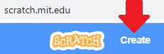 and you will come to a different screen.
At this point you do not need to have an account to use Scratch.
Later, if this is something you want to use you can make a Teacher Account and give each student their own account. If you want to make your own account it is very easy and that information will follow.
I do suggest you consider having a public “I am a teacher” account to share your projects (https://en.scratch-wiki.info/wiki/Project ) with your students and a second, private “I am learning to code and want to practice” account. But you don’t need that right now.

Here are some links regarding Educator Resources and Teacher Accounts:
https://scratch.mit.edu/educators/
https://scratch.mit.edu/educators/faq
https://scratch.mit.edu/discuss/youtube/7Hl9GxA1zwQ/
https://scratch.mit.edu/educators#resources
https://en.scratch-wiki.info/wiki/Student_and_Teacher_Accounts

There are three main parts to the Create Screen:
on the left is the Block Palette (https://en.scratch-wiki.info/wiki/Block_Palette );
in the middle is the Code Area (https://en.scratch-wiki.info/wiki/Code_Area )where you drag the blocks to make coding stacks;
and on the right is the Stage (https://en.scratch-wiki.info/wiki/Stage ) where you can see what happens when you code.
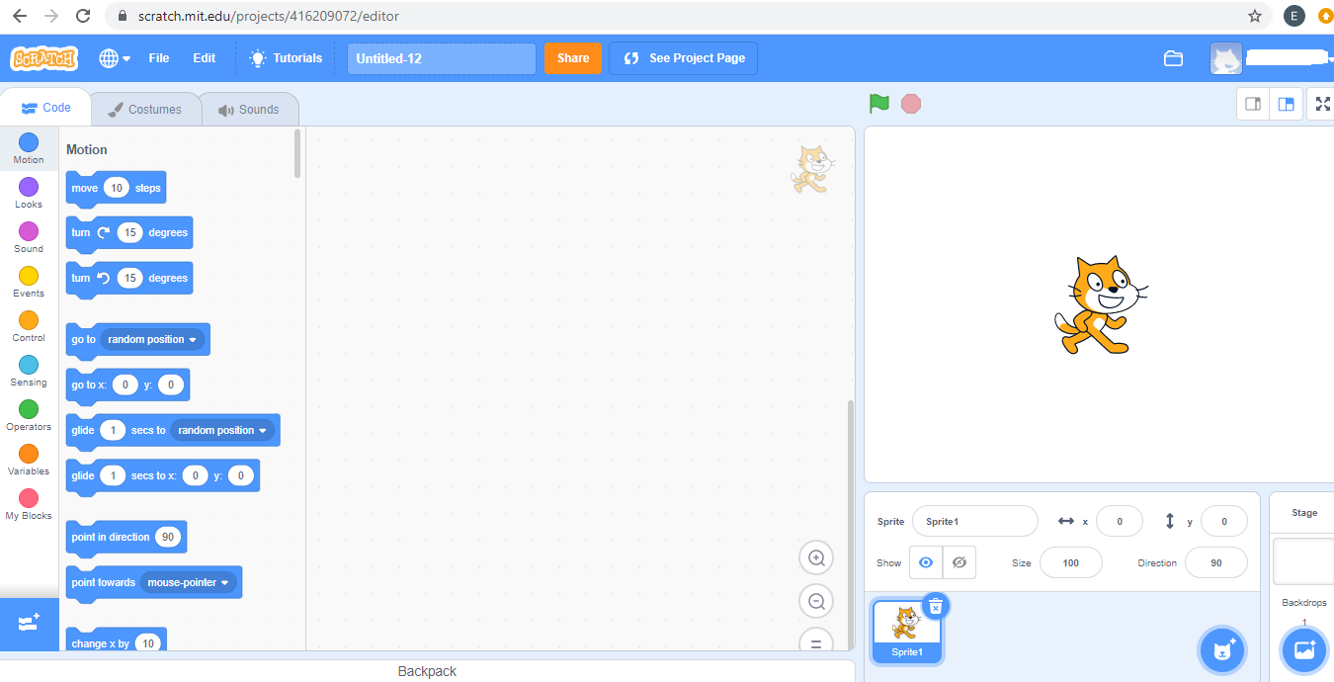
In the Block Palette there are three tabs 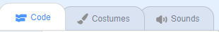 on top and a list of different kinds of blocks along the edge.
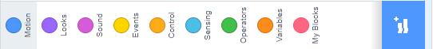
Multiple blocks are found for each of the types/categories of blocks and more can be added by clicking . (https://en.scratch-wiki.info/wiki/Blocks )
For example, for Motion: For Looks: For Pen Blocks:
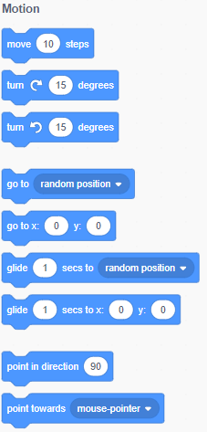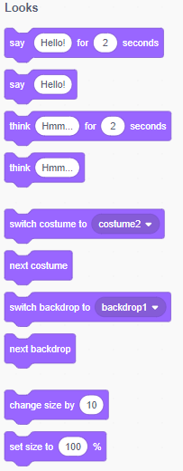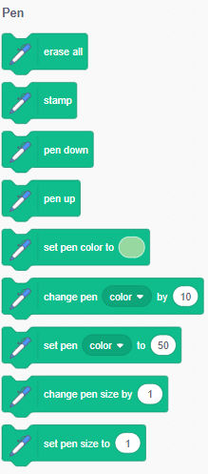
The blocks are colour coded for their category and you and your students will soon learn to find them quickly based on their actions. Information about each block can be found in the Scratch Wiki, for example
https://en.scratch-wiki.info/wiki/Blocks
https://en.scratch-wiki.info/wiki/Motion_Blocks
https://en.scratch-wiki.info/wiki/Move_()_Steps_(block) but you don’t need this information to start!
So, let’s get coding. Click on and drag the Move 10 steps block to the Code Area 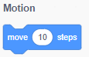.
There is a cat in the middle of the Stage. It is a sprite (https://en.scratch-wiki.info/wiki/Sprite ) (https://en.scratch-wiki.info/wiki/Libraries#Sprites_Library ) and sprites are the objects that do the actions in a project. Watch what happens to the cat when you click on that block. It moved! Not very far, but it moved to the right. Did you notice the 10 in the white circle? The coding inside the block “told” the sprite to move 10 pixels in the direction the sprite was facing. If you click on the number in the white circle you can change the distance travelled. Try these 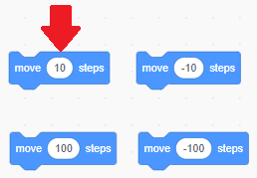 Underneath the Stage you should see the information about the position of the Sprite. To start with it was: 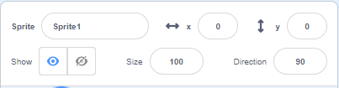 and with the Move 10 Steps block it should read
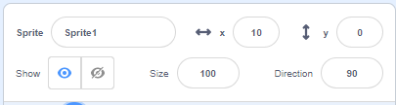 (x, y) as (0, 0) is now (10, 0) to account for the 10-pixel movement.
Ok, let’s get Scratch Cat to not only move forward but turn around. Remember, any block with a white area is a variable and can be changed. So, I changed the first position with the Go to x, y block to be the centre of the stage, move sprite 50 pixels, turn the cat, and move another 50 steps (pixels).
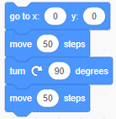 and ended here 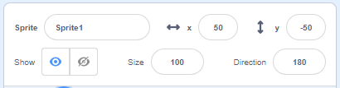

OK, two more things before you get to play around. Let’s have Scratch Cat talk. Sprites can talk two ways – visually and with a sound file. Go to the Looks block and drag over the Say Block, then type in whatever you want to add. 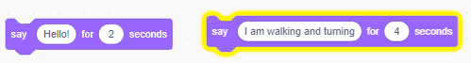
It will look like this on the Stage. 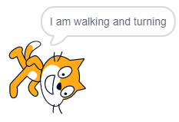
The yellow line around the block tells you what block actions is happening at the moment. For single blocks that is not significant but for a stack of many blocks it is helpful.
If you want to have the cat make a sound drag over 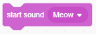 and add it to the stack.
Last items are adding an Event Block, When the Green Flag is clicked and two Control Blocks, one to have a wait time and the other a Repeat Block so Scratch Cat can get back to (0, 0).
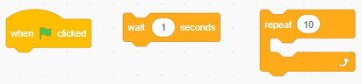 The stack looks like this: 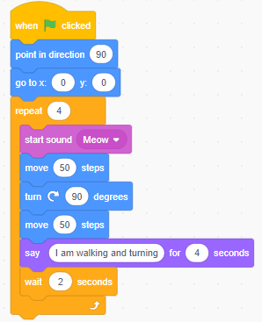 So Ready, Set, Get Coding!

Scratch Main Screen Information (scratch.nit.edu) 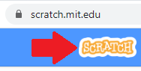
I mentioned earlier that this section’s information would be updated and personalized and here is what I meant by that. If you would like more information go to : https://en.scratch-wiki.info/wiki/Scratch_Wiki:Table_of_Contents/Front_Page
and when you hover over the different sections of the screen more information pops up.
For example, in the What’s Happening? section the links to what people are viewing will be different for each person who has an account and who follows other Scratchers. Scratch News will change as new events are scheduled. In this case, Scratch Camp 2020 is an August event and the New Scratch Design Studio presents a new topic/theme throughout the year. This is a screen shot from the first week of August 2020. Projects in the current Design Studio can be found if you scroll down below.
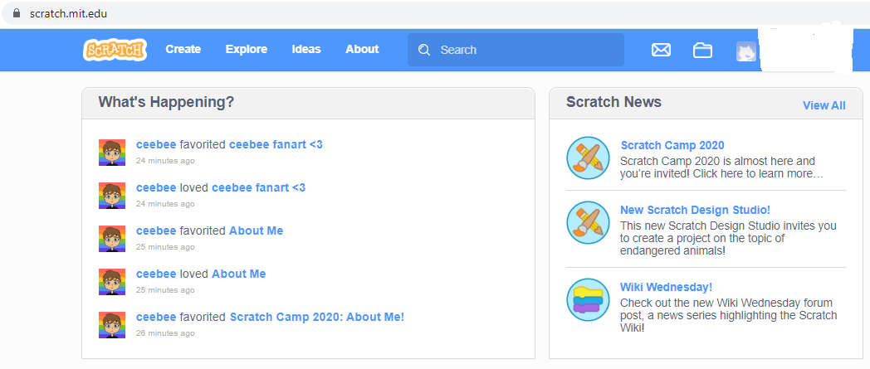

Featured Projects (individual coding tasks) and Featured Studios (projects grouped together by a common them or collected by an individual user). They are always updating with ones the global community is viewing.
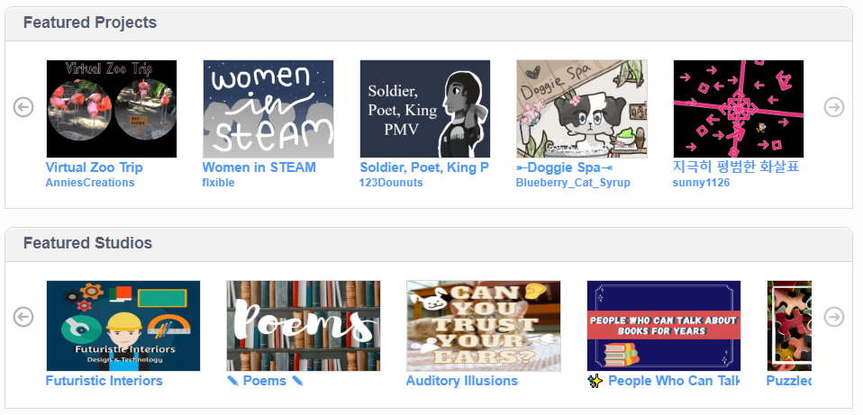
The Scratch Team selects popular users and they are given the chance to highlight the work of others, hence Curated by … The Scratch Design Studio projects are the ones based on the theme mentioned above in Scratch News.
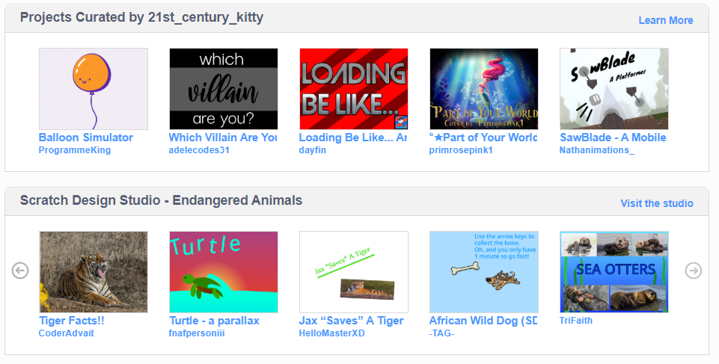
Projects Loved by Scratchers I’m Following is individualized for each person with an account. As you learn to code and view other’s projects you can make links to individual projects or follow the coder. What the Community is Remixing is constantly updating as more and more people view a project and want to make it their own by Remixing it.
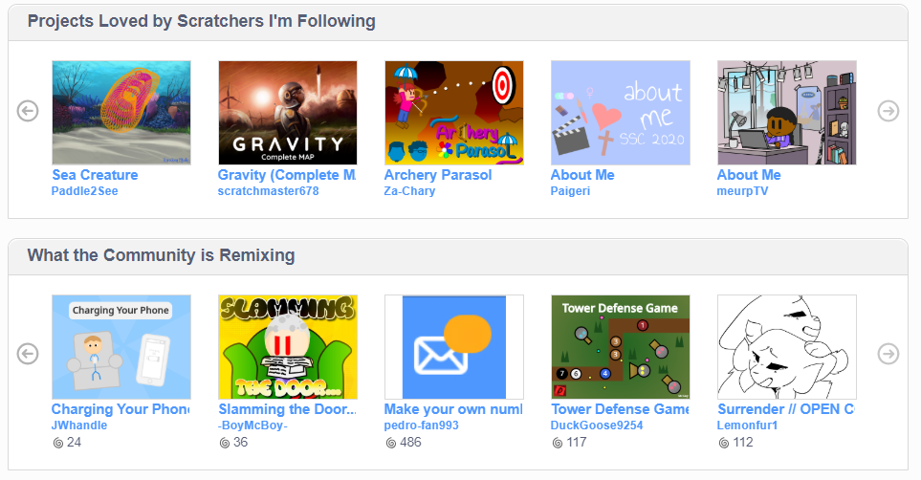

What the Community is Loving is another way the Scratch Team highlights popular projects. Notice the heart ♥ below a thumbnail of the project. The melon project has 572 likes and that means at least 572 people saw the project and tagged it. Beneath that are the links to various parts within the Scratch website.
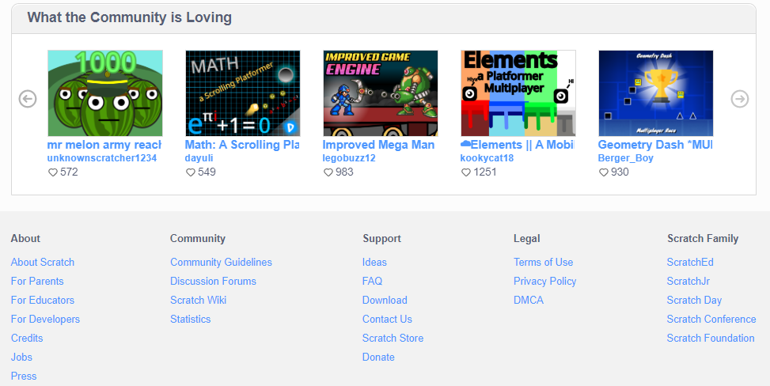
Notice at the very bottom you can change the language for Scratch. French Immersion or French Language students or ESL students can easily use Scratch to code.
