“Summer gets to be an old story.”
—Henry David Thoreau
T.S. Eliot called April the cruelest month, but in Austin, Texas, it’s September. Summer is winter here, and summer isn’t even officially over until September 22. The cursed sun pays no heed to anything official. You’re not out of the A/C until Halloween at the earliest. September here is just a cruel joke. When Northern Instagram fills with scarves and pumpkin spice lattes, your only solace is shorts in February. (Awful in its own way.) “Hot and sunny every day,” Bill Hicks mocked. “What are you, a fucking lizard? Only reptiles feel that way about this kind of weather.” It’s nothing right or natural. Nothing to be celebrated. Only endured.
From: https://austinkleon.com/category/newspaper-blackout-poems/

Blackout Poetry Links (Newspaper Blackout Poems)
Austin Kleon YouTube videos
Steal Like an Artist TEDTalk about Newspaper Blackout Poetry (11:14) and he mentions other poets. Besides these links there are lots of other links, images, and videos…
https://www.youtube.com/watch?v=oww7oB9rjgw
website: https://austinkleon.com/category/newspaper-blackout-poems/
Here is his talk at Scratch18 (53:00) https://www.youtube.com/watch?v=wB_y4BhmKRM&feature=youtu.be
Tom Phillips
http://www.tomphillips.co.uk/humument/essays/item/6261-pages-of-a-humument-tom-phillips-on-his-show-at-flowers-gallery-by-vida-weisblum
Main page: http://www.tomphillips.co.uk/
William Burroughs
http://www.openculture.com/2016/07/how-to-jumpstart-your-creative-process-with-william-s-burroughs-cut-up-technique.html (article and 3:00 video taken from a radio program from the 1950’s explaining the technique)
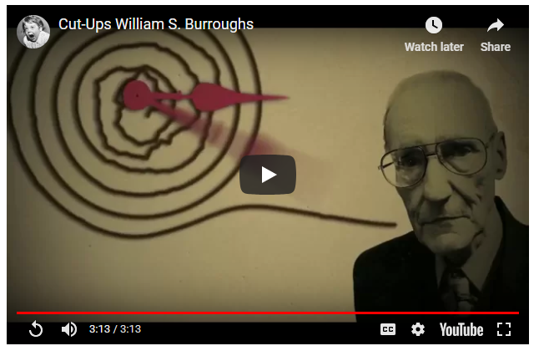
Also mentioned in Austin Kleon’s talk is Brion Gysin cut up art
and Tristan Tzara (https://www.poemhunter.com/tristan-tzara/ and https://www.poemhunter.com/poem/to-make-a-dadist-poem/)
In Austin Kleon’s blog there is a short entry and a short (1:45) video of how to make a Newspaper Black Out Poem https://austinkleon.com/2015/09/21/how-to-make-a-newspaper-blackout-poem/
A longer entry is at https://austinkleon.com/2014/04/29/a-brief-history-of-my-newspaper-blackout-poems/
More examples at http://newspaperblackout.com/

http://www.languageisavirus.com/creative-writing-techniques/william-s-burroughs-cut-ups.php#.XL3EOOhKjIV (cool site not only explains Burroughs (same video as Open Culture site and a second video as well) but has poetry “games” that involve computer programming like Mad Libs, etc.
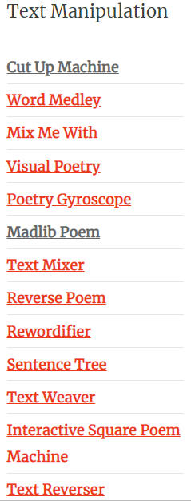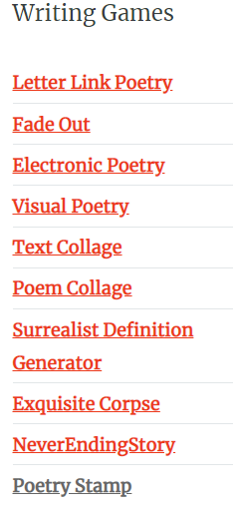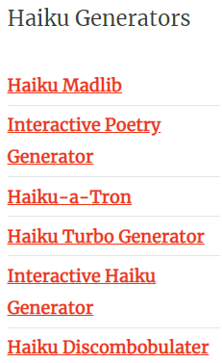
Adding Scratch and Makey Makey to Blackout Poems
Colleen Graves video (4:46) https://www.youtube.com/watch?v=TsYQC-RyWYc
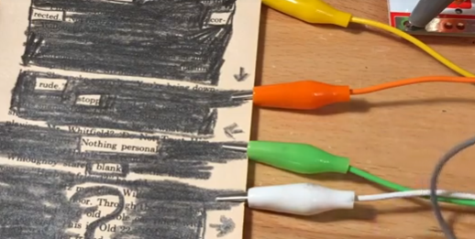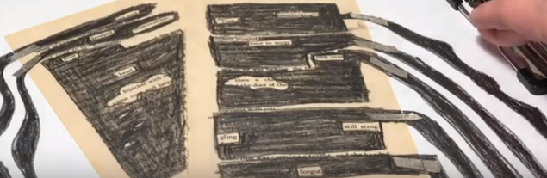
Here is the link to a lesson plan that accompanies the Colleen Graves video https://labz.makeymakey.com/cwists/preview/1781x
Scratch Tutorial Project on how to make poem: https://scratch.mit.edu/projects/167176782/
